**Name:- Dharan Gowda Superset id:-6387532**

**Create a React Application named “cricketapp” with the following components:**

1. **Create React App(cricketapp)**

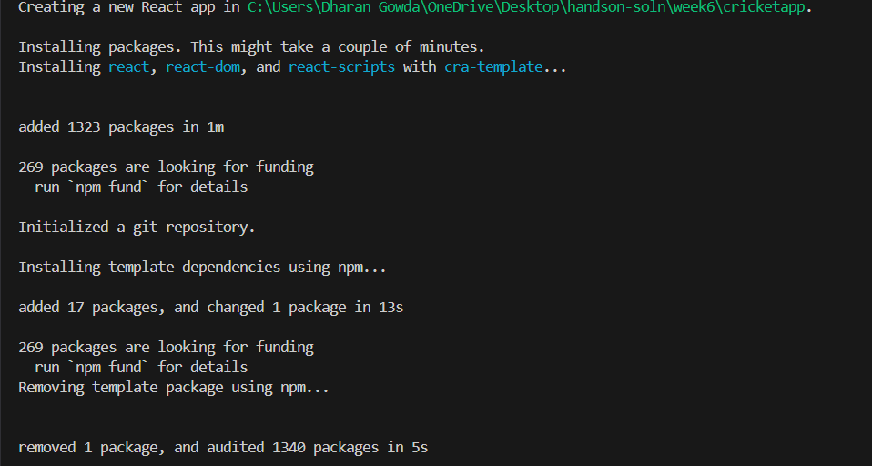

1. **Create ListofPlayers.js**

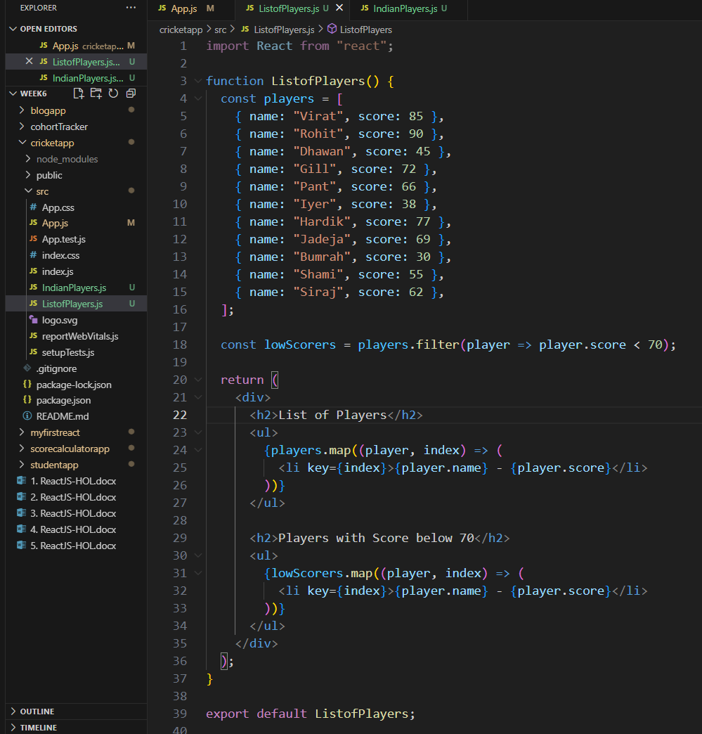

1. **Create IndianPlayers.js**

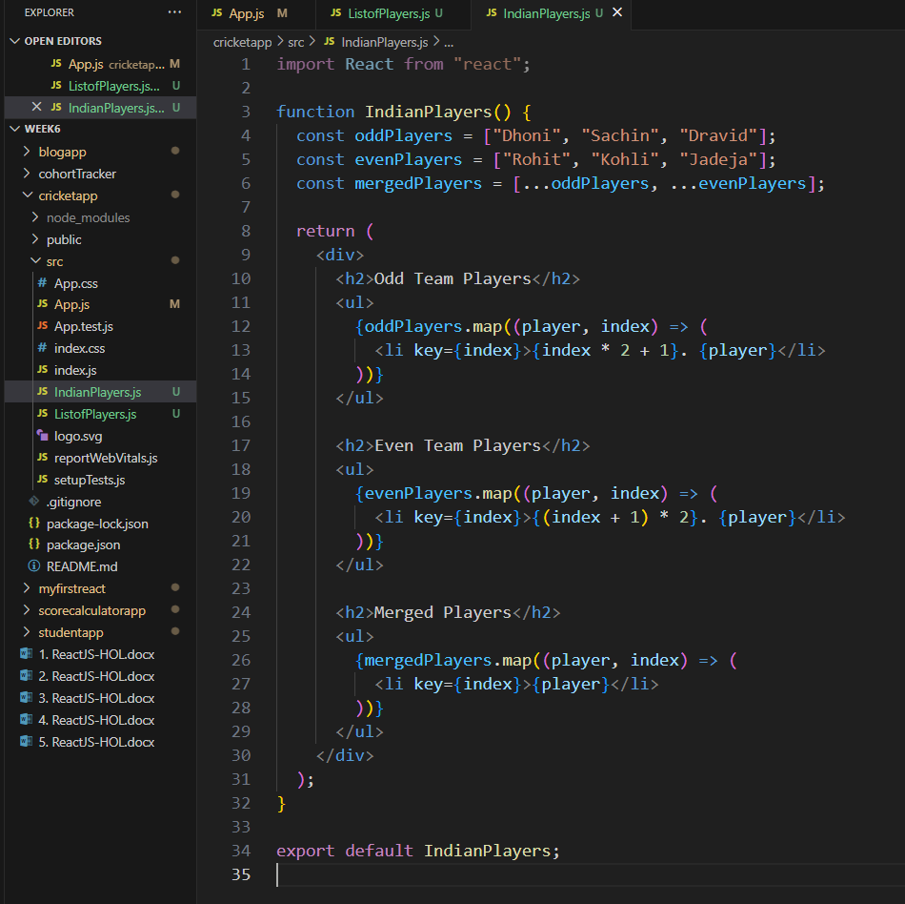

1. **Create App.js**

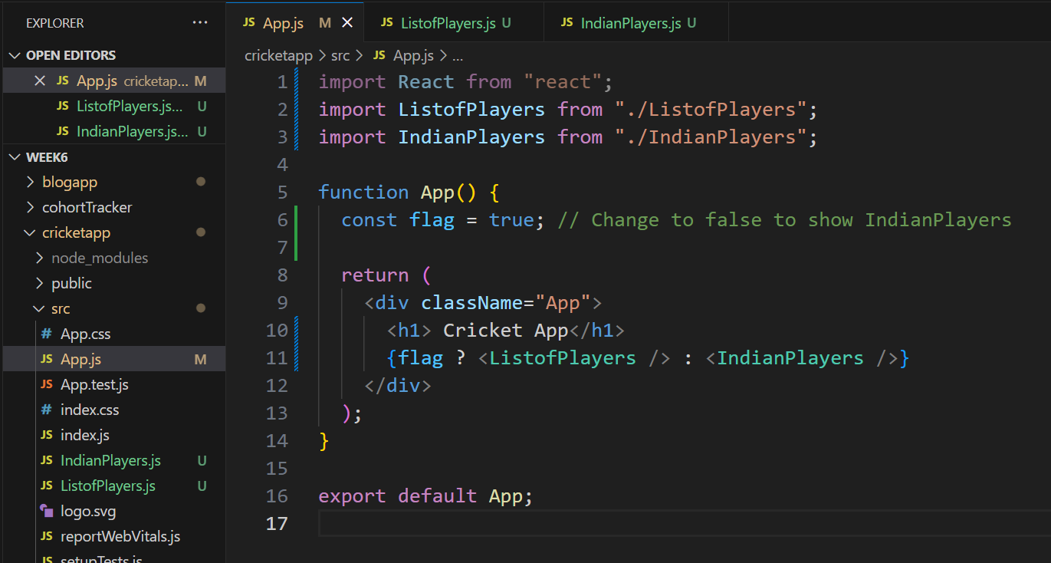

**5) OUTPUT:-**

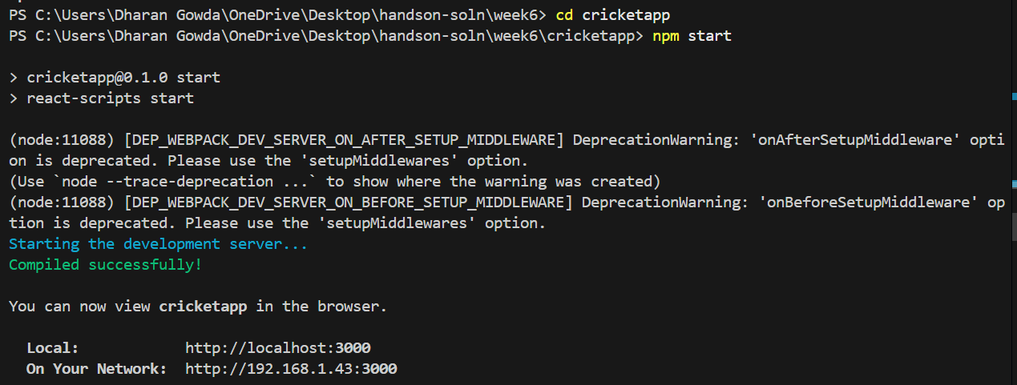

**When Flag=true**

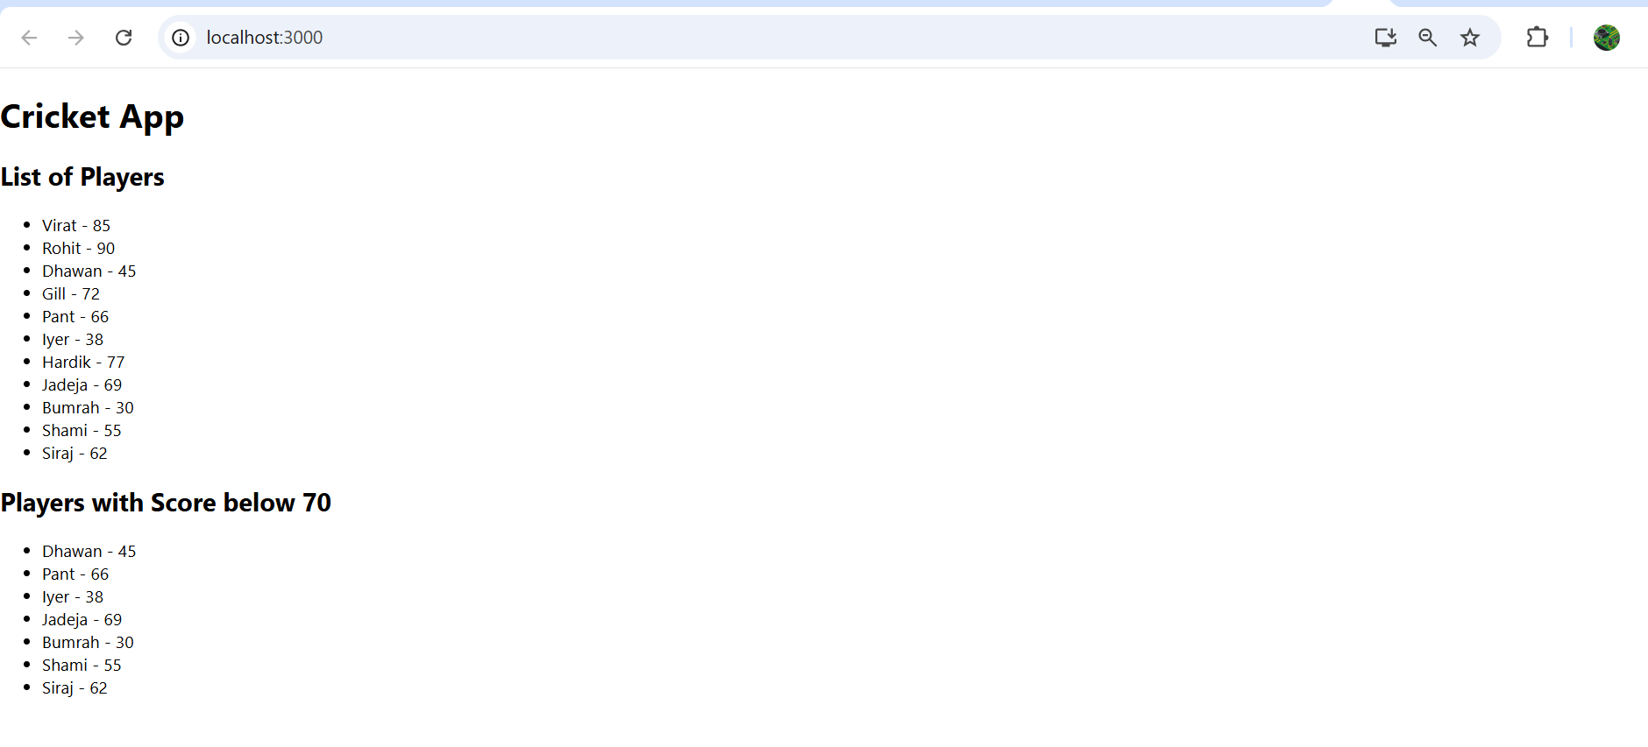

**When Flag=false**

